**Ask**

This is a request for a process to be able to configure the following settings for new Autopilot devices.

* Regional Format
* Language for non-Unicode programs

**Considerations**

* If possible, consolidate both settings in one script.
* Both settings must be configurable depending on which Region was selected during OOBE.
* The script must only make changes when running the first time. This is to prevent it from resetting the settings in case the user decides to manually change them later.
* If required, make sure the script only makes changes when running behind the ESP.
* Test and confirm that the provisioning process will not be affected by making these changes.
* Adhere to the standard process for code standards, documentation, testing etc.

## Regional Format

Allow us to set a **Format** based on the **Region** selected during OOBE (we already have a script ‘ EYSetRegionalFormat’ that does this for Autopilot devices today but it only sets it for the currently logged on user).

The format needs to be configured for all user accounts (including new user accounts) as well as the Welcome screen and the system accounts.

The solution will need to cover and implement all the country specific configurations for the regional format that are already in place in PCBuild today.

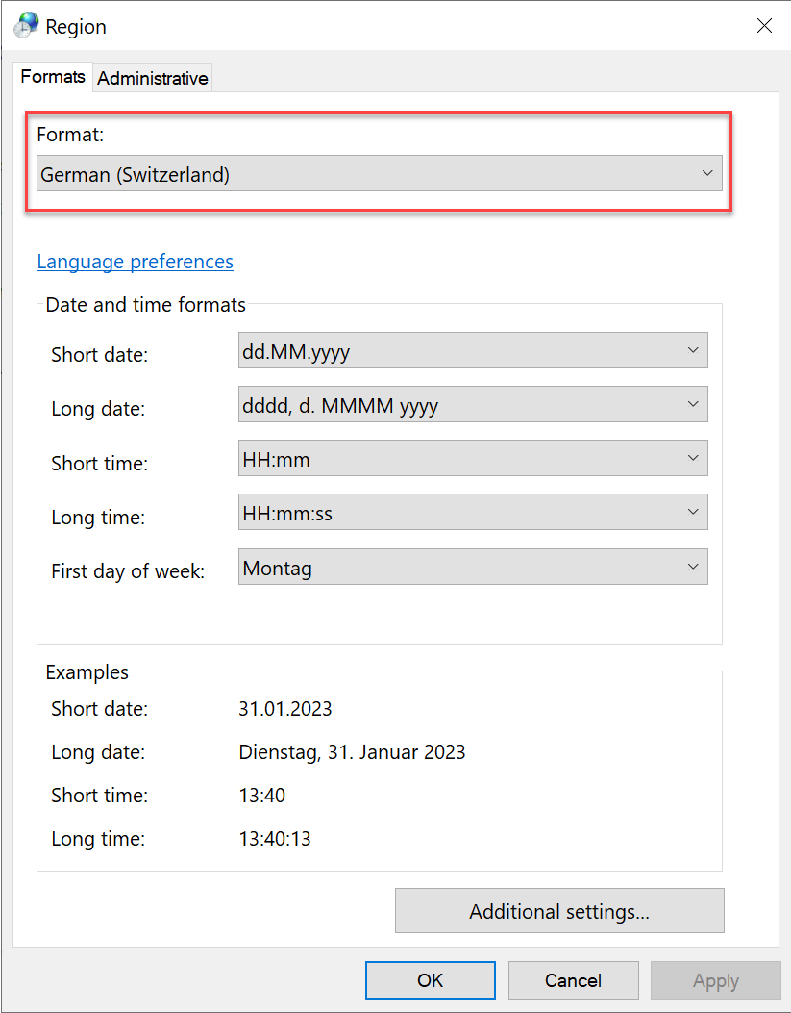

## Language for non-Unicode programs

# Set-WinSystemLocale

Allow us to set a language for non-Unicode programs based on the Region selected during OOBE.

The solution will need to cover and implement all the country specific configurations for the Language for non-Unicode programs that are already in place in PCBuild today.

